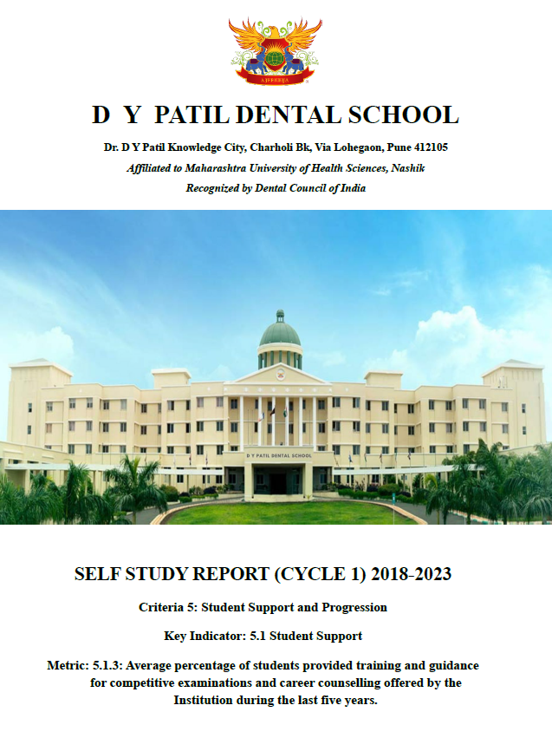

Year wise list  of students and certificates | https://dypds.com/dvv-pdf/5/5.1.3/5.1.3%20List%20and%20certificates.pdf

