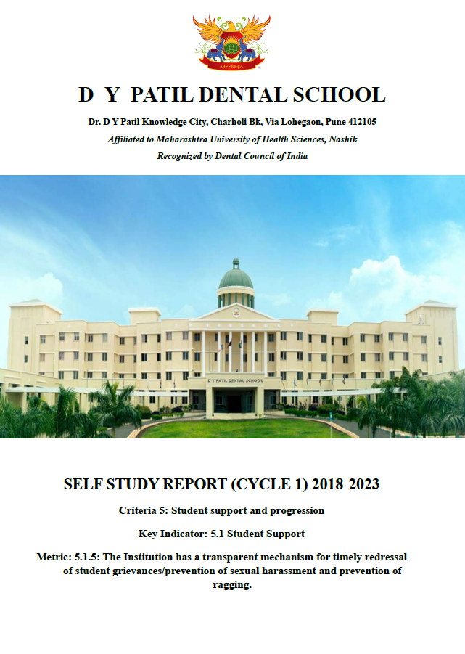

DVV response | Clarification | Link
Input edited as only circular and meeting details are given 1)Provide the document showing Adoption of guidelines of Regulatory bodies and mechanism of receiving student grievances (online/ offline) 2)Provide the Record of action taken for the same | We are providing the SOPs for the said committees which help us to adopt the guidelines. There was no reported incidence of sexual harassment / ragging. Hence, we are providing the details of programmes taken to avoid the incidences. | https://dypds.com/dvv-pdf/5/5.1.5/5.1.5%20sops%20and%20reports,%20circulars.pdf

